CIS11 Lab 2: LC-3 Basics with Input and Output
In this lab exercise, we will begin exploring LC-3. Review the below general description of LC-3 and complete the required tasks.

About LC-3
The LC-3 specifies a word size of 16 bits for its registers and uses a 16-bit addressable memory with a 2¹⁶-location address space.
The register file contains eight registers, referred to by number as R0 through R7. All of the registers are general-purpose in that they may be freely used by any of the instructions that can write to the register file, but in some contexts (such as translating from C code to LC-3 assembly) some of the registers are used for special purposes.
Instructions are 16 bits wide and have 4-bit opcodes. The instruction set defines instructions for fifteen of the sixteen possible opcodes, though some instructions have more than one mode of operation. Individual instructions' execution is regulated by a state machine implemented with a control ROM and micro-sequencing unit.
The architecture supports the use of a keyboard and monitor to regulate input and output; this support is provided through memory mapped I/O abstractions. In simulation, these registers can be accessed directly, and the architectural specification describes their contents. Higher-level I/O support is also provided through the use of the TRAP instruction and a basic operating system. The operating system provides functions to read and echo characters from the keyboard, print individual characters to the monitor, print entire strings in both packed and unpacked forms, and halt the machine.
All data in the LC-3 is assumed to be stored in a two's complement representation; there is no separate support for unsigned arithmetic. The I/O devices operate on ASCII characters. The LC-3 has no native support for floating-point numbers.
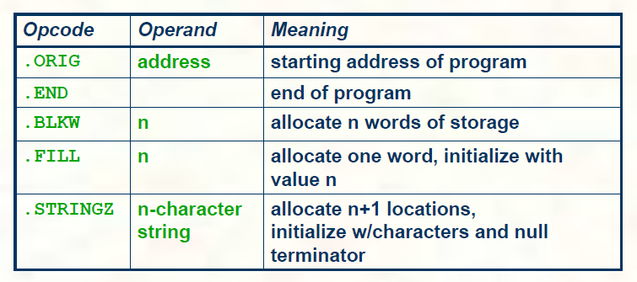
Format:
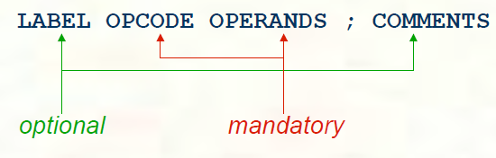
Opcode: LC-3 instructions (ADD, AND, OR…)
Operands separated by comma:
- Registers: R0 – R7
- Numbers: indicated by # (decimal) x (hex)
- Labels: placed at the beginning of the line, assigns symbolic names.
Example:
ADD R0, R0, R1 ; adds R0 + R1 and stores result in R0
ADD R0, R0, #5 ; adds R0 + decimal 5 and stores result in R0
ADD R0, R0, xA ; adds R0 + hexadecimal A or decimal 10 and stores result in R0
Pseudo-instructions for trap
Mystring = “Hi”; convert character from ASCII to numbers, then store

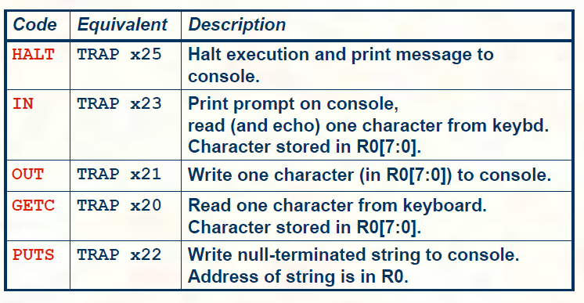

Download and Install LC-3 Simulator
- Visit https://highered.mheducation.com/sites/0072467509/student_view0/lc-3_simulator.html and download LC 3 Simulator Windows Version 3.01 (385.0K), zipped file.
- After file download is completed, right-click the file and choose 7-zip.
- Select Extract files and browse (… button) to USB flash drive and click OK button to decompress the downloaded file.
- Open USB flash drive or storage location to locate LC301 folder will contain numerous files that are necessary for the course lab exercises. *To avoid weekly download and installation of LC-3 Simulator, it’s best to decompress and store program files in USB flash drive.
- In LC301 folder, open LC3Edit.exe to launch LC-3 Editor.

Creating a “Hello World” program in LC-3
- In the Editor, input the following:
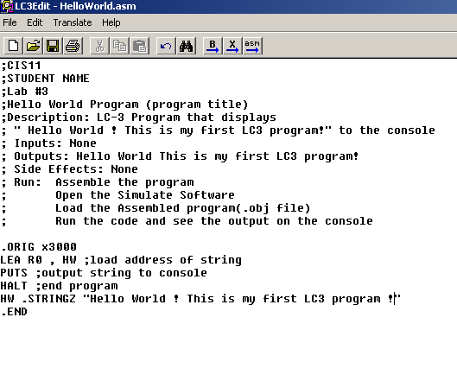
In this program, we use ; symbol for comments. For this lab and all future lab, you will be required to include course number, your name, lab number, program title, description, inputs, outputs, side effects and instructions to assemble and load the program (use as shown).

- Line 1: You want to begin the program at x3000 address, which is indicated as .ORG x3000
- Line 2: LEA R0, HW loads address of string with label HW to register 0 (R0).
- Line 3: PUTS instruction outputs the string to console.
- Line 4: HALT instruction terminates the program.
- Line 5: HW .STRINGZ “Hello World ! This is my first program !” is the declaration of string label.
- After you have input the program in LC-3 editor, click File, then click Save as, browse to USB drive and create a New Folder Lab 3 and input HelloWorld.asm for file name.
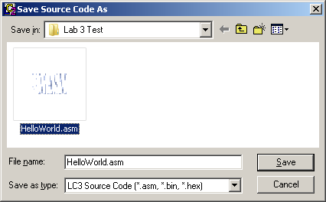

- Once the file is saved, click Translate, then click Assemble.
Once the program is assembled, numerous files will be created in Lab 3 folder, such as HelloWorld.obj (object file) and HelloWorld.bin (binary file)… The object file is used in the Simulator to show output in the console.
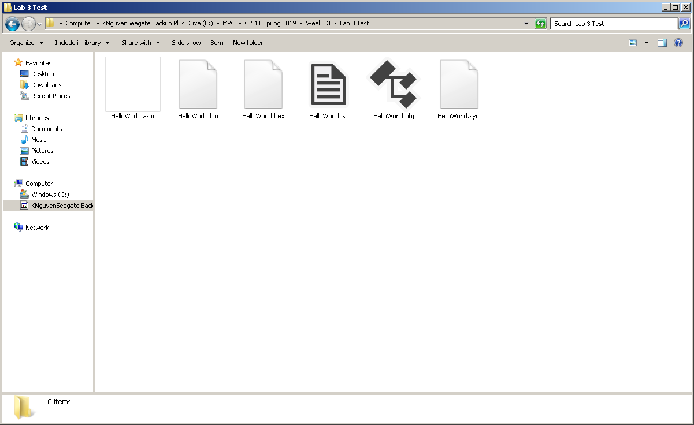

- Open LC301 folder and double-click Simulate.exe to open LC-3 Simulator.
- Once Simulator is opened, click File, then click Load Program browse to USB to locate HelloWorld.obj file.
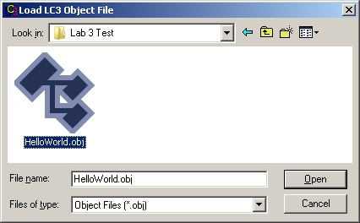

- Once the program is loaded in Simulator, click Execute and select Run.
- When the program runs, console window will display output. To see your console, click Console on Windows taskbar or desktop.
- Take screen capture of program input in LC3 Editor and output in console for lab submission.
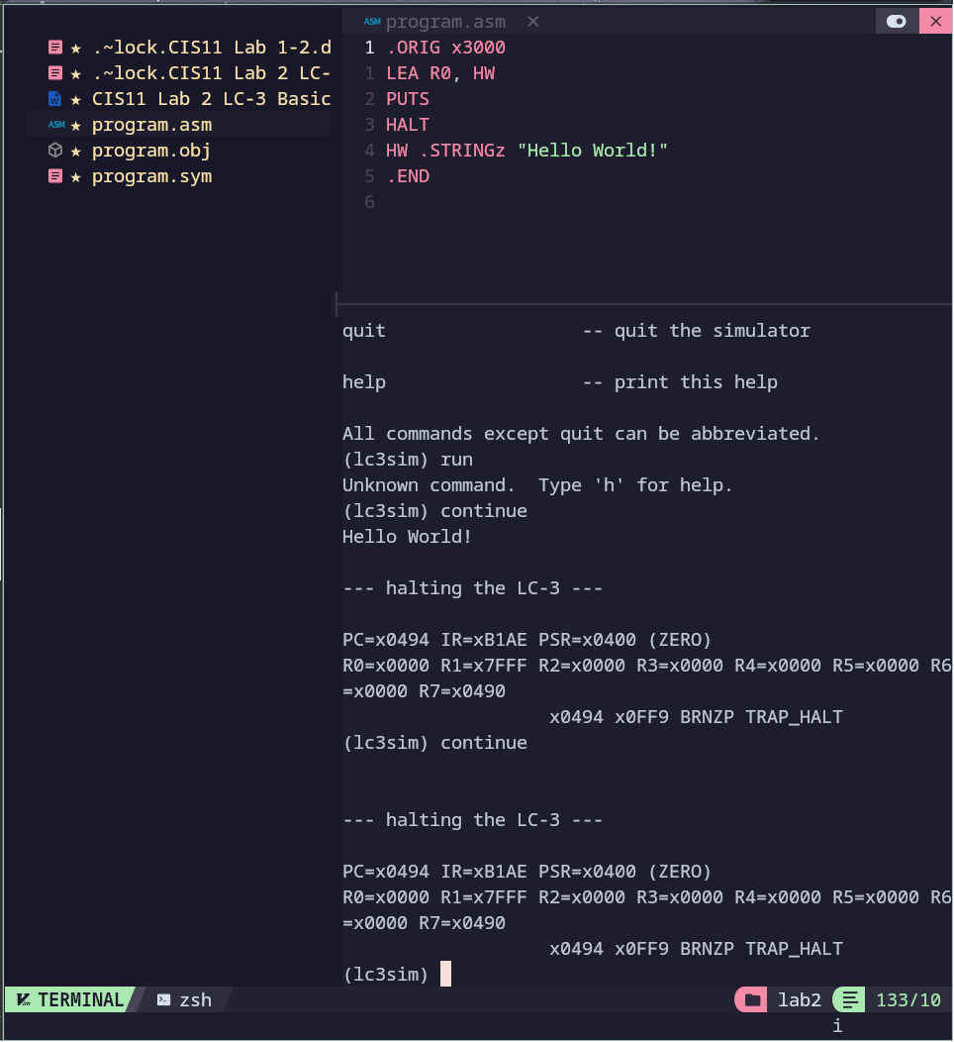

Creating another LC-3 program to display strings
- Create another program using the following strings:
“This is my second program in LC 3 !”
“I am learning assembly programming.”
The second program must fulfill the following requirements:
- Contain appropriate comments that contains program information. See step 6.
- Use appropriate Opcode, Labels, Address and Registers. *HINT: You can reuse the register in this program. You must re-invoke PUTS instruction to output multiple lines. Remember to use \n for new line.
Provide screen captures of LC3 Editor that contains code and Console displaying output.
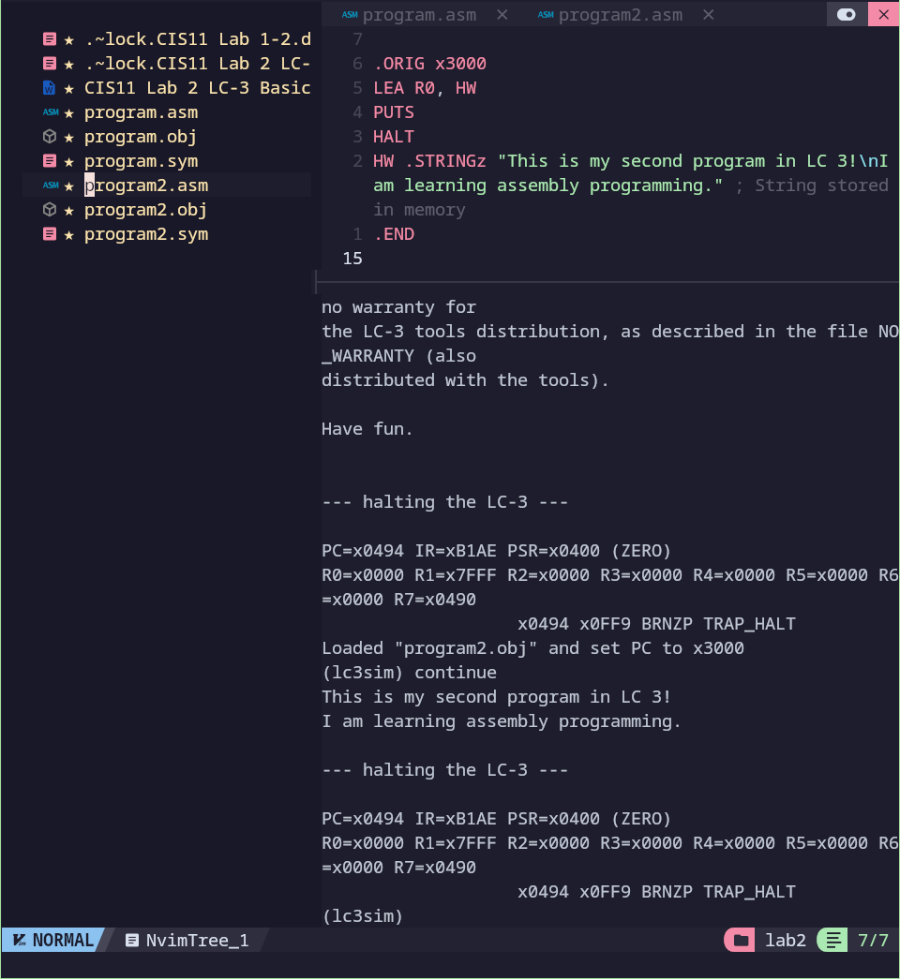

LC-3 Program using ADD instruction.
Adding two integers is done using the ADD instruction. In listing 1.1, the contents of registers R1 and R2 and added and the result is placed in R3. Note that the values of integers can be negative as well, since they are in two’s complement format. ADD also comes in immediate version, where the second operand can be a constant integer. For example, we can use it to add 4 to register R1 and place the result in register R3. See listing 1.1. The constant is limited to 5 bits two’s complement format.
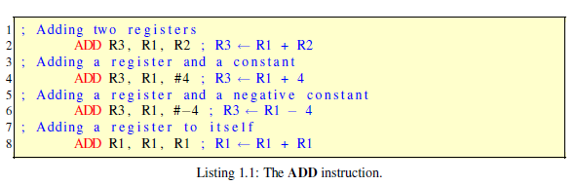
Note, as with all other ALU instructions, the same register can serve both as a source operand and destination register.
- You will create a program that outputs a hexadecimal value in console. Input the following code in the editor:
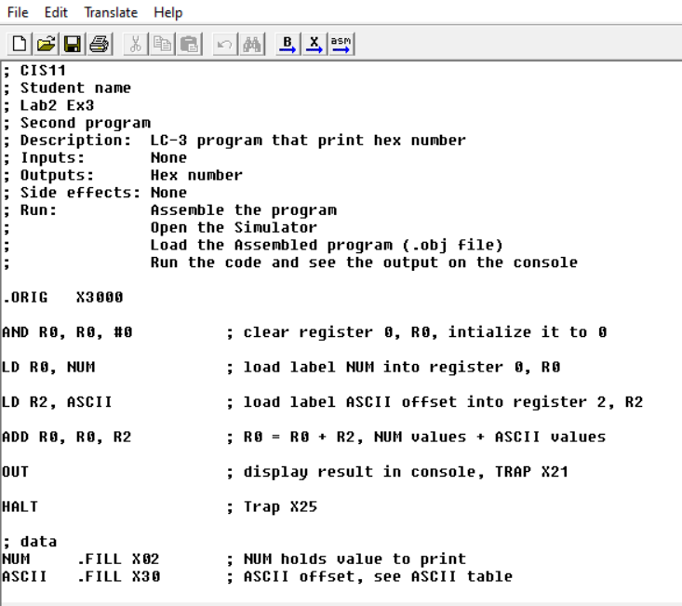
- Save file as PrintNumber.asm in Lab 3 folder.
- Assemble, load and run the program in the simulator.
- What is the output of your program?
It outputs 2
- Explain why the program results in the output from previous question.
The program load the x02 from memory at NUM, then it loads the ascii offset for numbers from ASCII. It add the two values and outputs R0, which is 2.
- Describe how you can change the program to output another number, such as hexadecimal 9.
Change the number at NUM to x09
- Provide screen captures of code and console output for lab submission.
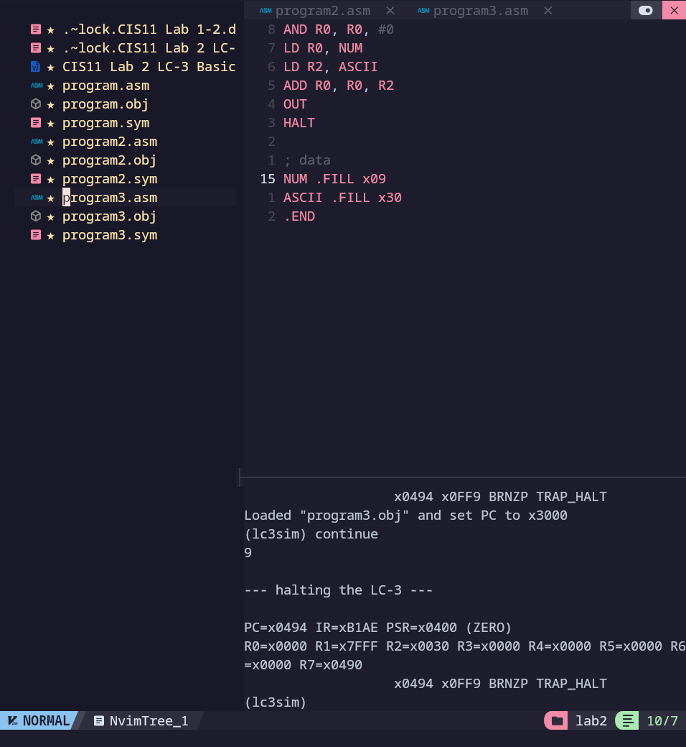
- In this task, you will create a program that calculates the sum of two inputs, then output the result in the console. In LC3 Editor, input the following code:

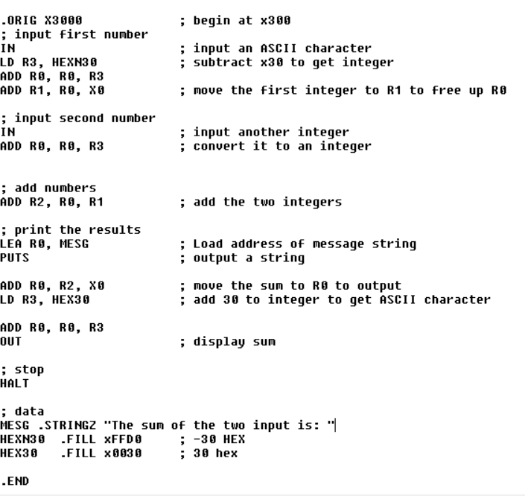
- Save the program as SumInputs.asm in Lab 3 folder.
- Assemble and run the program.
- Test the program input using numbers 1 – 5. For example: first input is 4 and second input is 5.
Take a screen capture of code and console output for lab submission.
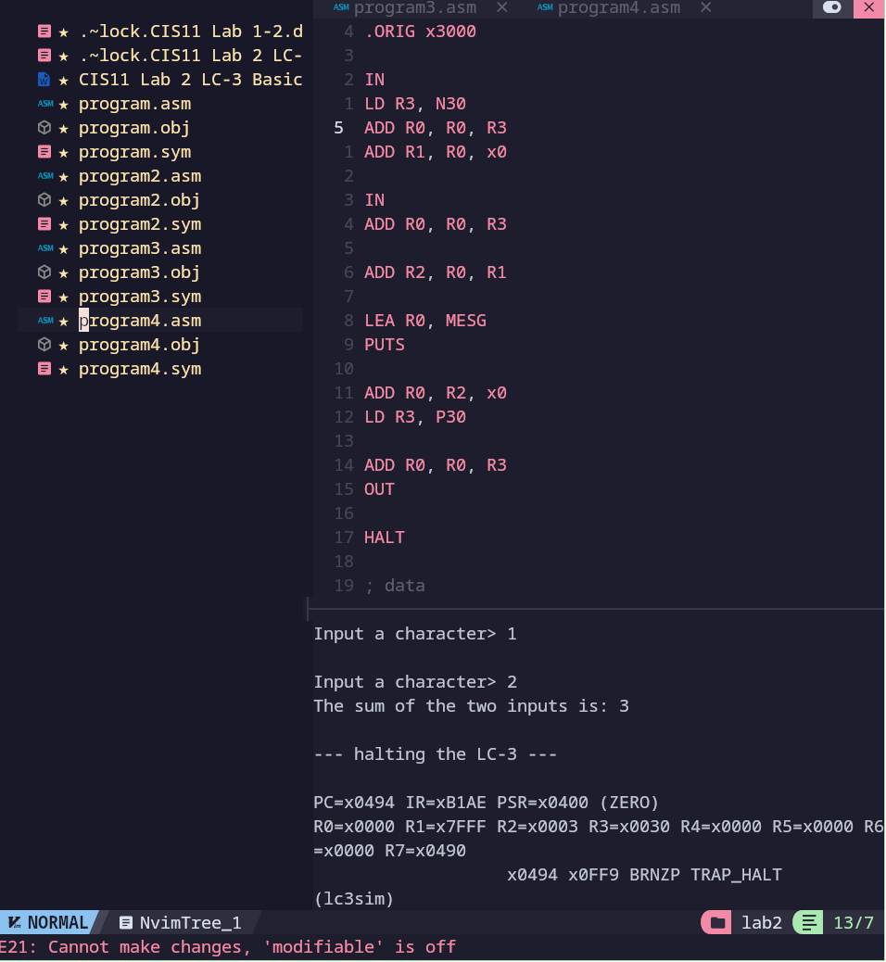
- Reload the program in simulator and re-execute.
- Test the program using inputs of numbers greater than 5.
- Describe the output result.
The result is a random ascii character, specifically symbols.
- Explain possible reason for such result.
There is no logic in our program to handle numbers greater than 9. As such we start outputting whatever characters are next in the ASCII table.
- Reload and re-execute the program in the simulator.
- Test the program using inputs of symbols, such as $, %, &…
- Describe the output result.
We start to get random capital letters.
- Explain possible reason for such result.
The program doesn’t distinguish between characters and actual numbers, as such it is just taking any character we input, getting it’s ascii representation, then subtracting 0x30.
- Save all files to USB and login Canvas to submit screen captures and answers.

